SEG3901

CO-OP WORK-TERM REPORT (Summer 2013)

NI-DIRECTOR

Nakina Systems

By
Samira El-Rayyes
6439366

Presented to Professor Stéphane Somé
Software Engineering Academic CO-OP Coordinator

University of Ottawa
September 13, 2013

Table of Contents

Abstract 4
I. Introduction 4
II. NI-Director 6
- Network Elements 6
- What is NI-Director? 6
III. Testing 7
IV. Reporting 9
V. Other Projects 10
- System Upgrades 10
- Adapter Testing 11
VI. Recommendations 12
- Nakina Systems 12
- CO-OP Program 12
VII. Conclusion 13
Bibliography 14
Appendices 15

LIST OF APPENDICES

A: NI-Director, Desktop – Screenshot 15
B: NI-Director, NE Manager Application – Screenshot 15
C: NI-Director, NE Manager, NE Configuration – Screenshot 16
D: NI-Director, NE Security Application – Screenshot 16
E: NI-Director, NE Security Template Application – Screenshot 17
F: NI-Director, Log Manager Application – Screenshot 17
Abstract
Engineers in the software field do not often consider Product Verification when first thinking of an area of work. Although all software engineers understand the Product Verification Process in software development, younger software engineers might not fully understand its importance. The main purpose of product verification is to ensure that a product meets customer requirements and specifications and that it performs as expected. My main duties throughout my work term as a Product Verification Student at Nakina Systems were focused on the Product Verification Process of one of the company's products, NI-Director. I was responsible for testing this product by writing test cases, executing test steps and reporting issues in the appropriate manner. Moreover, I performed some other tasks such as regularly upgrading the testing system and testing adapters. I had the privilege to experience employment with Nakina Systems, and I was fortunate enough to see for myself the importance of product verification in the industry, all while learning how to write proper test cases and the testing process. My engineering background has been highly beneficial to me while acquiring new technical knowledge. Moreover, I gained interpersonal and team skills by working with influential individuals who allowed me to learn from their expertise, as well as I expanded my network to include experienced professionals. This work term was highly critical to my development as an engineer and a growing member of the high-tech community.

I Introduction

For my second COOP work term in Software Engineering at the University of Ottawa, I worked for Nakina Systems from April 29th through August 30th, 2013. I was hired as a Product Verification Student under the supervision of Trelaine Farrow, acting-manager of the Product Verification Team. Nakina provides Network Integrity Management solutions to the telecommunications industry for countries all over the world. With an American office located in Boston, Massachusetts, the Nakina Systems head office is located in Kanata, Ontario.
Within my first few days at Nakina, I was introduced to the members of the Product Verification Team and other teams that they work closely with, such as the Design and Development teams. By the end of the first month, I had nearly met every employee in the company. I was also fortunate enough to have to the opportunity to take part in a multiple events throughout my term that focused on developing interpersonal skills such as team-bonding activities and lunch potlucks with the company.
My performance goals from the beginning of the work term were to learn efficiency while practising with coding languages by writing dozens of new scenarios in Java, upgrading systems using bash, shell and python scripts as well as Linux commands. I was also aiming to improve my oral and written communications skills during the meetings and small discussions with coworkers by writing JIRA bug reports and weekly status updates and verbal discussions about issues found while testing. Lastly, and certainly not least, my third performance goal for the term was to become more confident in my work while creating test cases and during general product verification procedures by not shying away when my test cases fail, but rather to learn form my mistakes and implement what I have learned in the next set of test cases.
As learning objectives for this work term, I wanted to develop a sound competency of scripting by testing a number of Nakina's products on a variety of systems that would have to be regularly upgraded, and then automating that procedure. I also wanted to enhance my testing skills, which was to be accomplished by working on the verification of many of Nakina's products and participating in the full Product Verification Process.
In between working on different projects, I had the opportunity to work with many types of people and try other kinds of testing. My main duties included testing one of Nakina's larger products, NI-Director. My primary role was to write test cases and perform test steps to verify the software before shipping it to the customer. Every couple of days, I would upgrade the verification system for all Product Verification members could use the latest builds and fixes for their testing. Lastly, I did a bit of adapter testing and touched of automating the upgrade process.
This report will provide an explanation of the primary product that I tested during my term, NI-Director. Furthermore, a summary of the testing and reporting procedures used at Nakina will be described. I will also briefly explain other projects that I have worked on and the challenges that came with each one. This report will present observations that were made by me, as well as the lessons that I learned through this experience. To conclude, my work term with Nakina Systems has significantly expanded my knowledge in thorough software testing and its importance in the world of software development.

II NI-Director
Nakina Systems offers a number of network element management solutions to customers world-wide. While the telecommunications industry is vast and complex, a brief description of what Nakina's NI-Director is outlined below.

- Network Elements
A network element, often abbreviated to NE, is a logical entity connecting at least one physical device that is manageable. As described in the Telecommunications Act of 1996, an NE means “a facility or equipment used in the provision of a telecommunications service.” This includes features, functions and capabilities allowable by the NE which may include but is not limited to databases, routing, signalling systems, information collection or transmission, and other telecommunications services. There are different connection methods for network elements: wireless, ethernet, television cable and telephone lines.
Nakina's products are created to facilitate and speed up network upgrades and new installs. They reduce the separation between the gold standard network design and the network in operation by implementing online auditing, discrepancy checking, and locking down the network with centralized security management.

- What is NI-Director?
One of Nakina Systems' older products is called NI-Director. It is an Element Management System that allows customers to manage devices and allows fault management and performance monitoring. NI-Director allows operators to run and schedule backups, push upgrades, and ethernet provisioning. Before using NI-Director, just as with any other product, it is important to be familiar with the detailed functionality of each managed network.
During my term with the Product Verification Team, one of my goals was to improve my public speaking and communication skills. As I attended dozens of meetings throughout the semester, I was given the opportunity to host a meeting of my own after the I completed development of a set of test cases for the NI-Director Webservice to review my test cases with the developers of the feature. At the meeting, I had to go through all of the test cases that I had written up and collect comments and suggestions from the others. As nervous as I was to be explaining this to members who knew the software better than I did, I found this to be a positive experience. It was an important step for me as I was able to directly take constructive feedback on my test cases and then apply my new knowledge to the rest of the test cases. Preparation for this meeting included being comfortable with the software and I had to know all of the terminology involved, as well as be prepared to discuss the test cases that I had written, and through this process I successfully accomplished my goal of improving my communication skills.
Personally, I found that product verification can be relatively simple yet thorough and provides a different perspective on software development. It acts as a filter before submitting a release to the customer, in the sense that it is used to investigate everything and insure, as much as possible, that unknown system issues are not delivered to the customer. Testers continuously practice efficiency, patience, and attention to detail. This being said, the testers are also always learning as different issues are found and reported over the course of multiple projects.

III Testing
My primary role on the Product Verification Team comprised of testing the products before delivering them to the customer. The product verification process is described in this section.
First, it is important to acknowledge the difference between a failure, defect and error. A failure in the system is defined as an unacceptable behaviours exhibited by the system. This is distinct from a defect in that a defect is a flaw in any aspect of the system including the requirements, the design and the code, that contributes, or may potentially contribute, to the occurrence of one or more failures. Errors, on the other hand, are inappropriate decisions by a software developer that lead to the introduction of defects into the system. Testers are responsible for detecting any issues in the system and classifying it as a failure, defect, or error, which also classifies the issues' urgency when it comes to fixing it. The following describes the general procedure to testing customer products.
There are many steps in the product verification process. Firstly, testers are assigned to develop test cases for all of the different components of the product. Typically, a tester will take care of writing test cases for some components and other testers can cover the test cases for the other components. A component is usually identified as a separate application within the software. Writing test cases is a delicate procedure, as the tester needs to ensure that the test cases are equally efficient and effective. All functions of the component need to be tested, but at the same time, repeating the same action in multiple test cases should be avoided to save time. For example, to test the functionality of a feature with multiple options, using different combinations of the features for each test case would be a good way to verify that the each part of the feature is working without wasting too much time on re-testing the same action. Furthermore, test steps need to be as concise as possible and each test case must represent just one functionality. The scenario that needs to be avoided is that within a test case, all the test steps are successful except for one, which would then result in the entire test case to fail.
The next step in testing a product would be to perform the test steps of test cases. This step is fairly straight forward, but does require a thorough understanding of the product before proceeding. Nakina uses ApTest Manager, which is a Web-based which offers fast and productive test management, to keep track of test cases and their status'. The tester's duty is to follow the test cases as written, and identify it as a pass or fail. If a test case is failing for some reason, it becomes the testers responsibility to properly report this issue in the appropriate manner. More details about reporting issues are discussed in the next section of this report.
After the developers submit a fix or solution to the issue, the tester will then retest the issue for confirmation. Ideally, this needs to be done as soon as possible, just in case the fix did not resolve the issue or causes more issues and it needs to be looked at immediately. If the issue is resolved, however, then the JIRA report can be closed.
I find that product verification is not well understood or as appreciated as it should be in the opinion of other student software developers. Testing is not as easy as it sounds, although many would argue that testing software must be easier that writing the code or developing the product. However, I can attest that they are two completely different tasks, and each comes with its own challenges. To properly test any produced work, all test and use cases must be verified. Testers have to put themselves in the position of the customer, consider all options that the customer might think of, and make sure that the software responds appropriately to all actions performed with it.
I did really enjoy testing Nakina's products, especially NI-Director, because it was interesting to be able to analyze software from the point of view of a customer. Being someone who usually pays a lot of attention to detail, I was able to apply my “pickiness” to my job. Perhaps that I will one day find myself in a similar task again, as I think that I would enjoy it and I would really appreciate exploring deeper levels of testing.

IV Reporting

Being in the Product Verification Team meant more than just testing the products, but it meant that I had to exercise communicating and reporting issues or defects, once discovered, to the appropriate people. There are various forms of reporting that are put to use at Nakina Systems, and the following section will explain more about them.
The most common reporting method was done via JIRA, a project tracker used by the company to document, organize, and assign issues to members responsible to following up on the them. When a tester recognizes a failure or defect in the system, he or she must properly raise this as a JIRA issue. For JIRA bug reporting, the most important field is the title. This must be as precise and clear as possible to make it easier to identify. The problem needs to be clearly explained within the description of the JIRA, and the expected behaviour must be obvious. Also, the issue's impact on the end user needs to be included, as well as its severity and the conditions user which this issue is reproducible. A properly reported JIRA issue should be as detailed as possible, such that the developer addressing the issue can understand the problem or any other tester can pick up the issue for retest should it be necessary.
Aside from the formal JIRA reporting system, frequent technical communications between team members and employees are very important. Consulting others before raising an issue as a JIRA bug is sometimes required when it is not evident if the issue is a known issue or if it is actually not an issue at all. Methods of communication include mainly technical conversations during meetings and communication by email. Furthermore, communication skills are used for weekly status reporting, where a summary of the week's activities are submitted to the manager for review.
It may not have been evident at first, but oral and written communications skills have shown to be crucial skills for software testers. Confidence and comfort when speaking to coworkers is important in order to be able to engage in technical conversations with coworkers, especially those from other teams such as Development and Design, to give detailed explanations of Verification defects. It is just as important to be able to write clear and concise descriptions of these defects for JIRA tracking or email correspondence. Failing to be communicate effectively would ultimately lead to confusion within the company and potentially result in low quality products.

V Other Projects

During my four months at Nakina Systems, I had the chance to explore other areas of work as part of the Product Verification Team.

- Upgrading
Probably my most frequent task throughout the term was to upgrade the system running the NI-Director product. Whether I was actively testing the system at the time or not, I was upgrading the system on a regular basis. Depending on which stage of the testing process the team was on, time between upgrades ranged from approximately three days to three hours.
There would be numerous reason to upgrade a system. As the product verification team is testing a product and reporting bugs to the development team, the developers commit fixes to these bugs and load new builds of the product with the issues addressed. To retest these issues, the system needs to be upgraded to the newest build. Sometimes, the problem is not so much with the product than it is with the framework, and this is another reason to upgrade to a new build.
For upgrading the system, I used the application called PuTTY Connection Manager to connect to system servers. Once connecting to the admin server, I then used Unix commands to navigate and execute the proper commands for a clean upgrade. First, the web servers must be shut down, followed by the business tier servers. Uninstalling the current build is the next step, then cleaning and fetching the build packages to get the newest loads from the load build server. Once the new build tags are retrieved, they can be installed on the still shut-down system, and only when it is complete, the business tier then the web servers can be started up again.
This process taught me a lot, as I would occasionally come across new issues while upgrading the system and I would learn more from coworkers explaining these issues to me and how to overcome them. I eventually became very competent with these upgrades, such that the Customer Support Team were asking me questions and I would show them how to do certain steps of the process.
- Adapter Testing
Another area of work where I helped was with the testing of network adapters. A network adapter is a computer hardware device that is programmed for a specific group of network elements. When getting near the release deadline of NI-Director, the members working on adapter testing needed some help finishing off performing the test steps for certain adapters, so I was assigned to help with this area.
Testing adapters involves testing all the features that the adapter is supposed to support. Every adapter comes with its own Adapter Release Notes, which is like a manual for the specific adapter that provides detailed descriptions about its functionality and its limitations. The first step to testing an adapter is to read the release notes. Then you can proceed to perform the test steps in each test case in the test set. If one step in the test case fails, the whole test case fails and it needs to be reported to the appropriate developer. In some cases, new limitations or known risks could be discovered while testing an adapter, and it is then required to include them in the next version's release notes.
This task being outside of my level of comfort, I was able accomplish this task by reading many supporting documents and asking a lot of questions. Ultimately, this forced me to practice self-teaching and it helped increase my confidence level by require to ask my manager and other members of the team for guidance.
Personally, I found testing adapters to be my least favourite task that I have performed during this term. The most likely reason for this is that I did not have any background knowledge of the adapters before jumping into testing them. Nevertheless, it was refreshing to learn so much about a different section about the team in such little time. After the testing was complete, I appreciated the challenge as I found my understanding to have increased significantly.

VI Recommendations

After completing my second work term with Nakina Systems, I have come up with a few suggestions that could have possibly improved my CO-OP experience.

- Nakina Systems
I sincerely believe that Nakina Systems was a great place for a CO-OP placement. Everyone that I have met or worked with was extremely welcoming and ready to help and mentor me with anything I needed throughout the term.
The most helpful of these people was my manager. During the first couple of weeks, and throughout the entire term, she spent many hours teaching me everything I needed to know, from how the testing procedure works to writing weekly status updates to reporting product bugs on my own. It was a great environment to learn important skills such as how to work in teams on one project as well as more technical skills such as upgrading systems using Unix commands, writing test cases and running them efficiently.
I believe that this was an important position for me to have as a CO-OP student, as it is related to my program yet it is a popular position for software engineering students to take. Although I was not involved in much coding, I was able to look at software at a completely different angle, from the customer's point of view, and analyze the functionality and usibility of the products that Nakina was selling them. For that reason, I would recommend this placement to other junior software engineering students.

- CO-OP program
For this work term, I was able to find my own placement early on in the school year. The CO-OP office made the process of making this placement with Nakina count as part of my work term very simple. Previous help with preparing for an interview helped when it came to my interview with Nakina.
I would maybe encourage the CO-OP office to communicate a little more with their students throughout the work term. The advantage to doing so would be that students will keep in mind that CO-OP is a credited program and it would keep them up-to-date with what’s new in CO-OP as well as with upcoming deadlines.
In general, I found the CO-OP office very reliable. Every time I had a question, I called in and got an answer immediately. It’s a program that I highly recommend!

VII Conclusion

In conclusion, it is evident that the verification of a product, such as Nakina's NI-Director, needs to be thorough and complete. After four months of performing test cases I have come to understand the real importance of proper product verification and its impact on the software development process. With the future advancements in technology, it is my opinion that product verification will become more demanding as software complexity increases and customer expectations are raised.
Throughout my work term, I was able to relate some concepts and knowledge learned through my classes and personal experience to my daily tasks. Through new challenging projects and assignments, I am able to pick up many new lessons and will incorporate such information into future applications. I had the chance to experience all aspects of verification for one of the company's major products that exercised my new software testing skills. I would recommend this position to any other software engineering, computer engineering or computer science student looking for a work term, as it provided an eye-epening perspective on software engineering from the product verification point of view.
I would like to sincerely thank all employees of Nakina Systems for granting me the opportunity to be a part of their group and to learn from their expertise. I gained valuable hands-on experience with products such as NI-Director as well as I expanded my knowledge about testing in general. Most importantly, I gained interpersonal and team skills by working with a supporting team and manager who dedicated their time to teach me. I valued my time at Nakina and hope to be able to carry on all that I have learned into my future projects.

BIBLIOGRAPHY

[1] Nakina Systems Overview – Nakina Systems, http://nakinasystems.com/company/company.php, visited August 11, 2013

[2] “Telecommunications Act of 1996”, fcc.gov, http://transition.fcc.gov/telecom.html, visited August 20, 2013

[3] “Networking”, Jeffrey S. Beasley, Pearson Education, Inc, 2004

[4] Trelaine Farrow, Nakina Systems Product Verification Manager

[5] NI-Director User Guide, Release 8, NI-DirectorUserGuideJuly16.pdf

[6] NI-Director Operations Installation Guide, Release 8, NI-DirectorOperationsConsoleInstallationGuideR8April02.pdf

[7] NI-Director Operations Console Guide, Release 8.3, NI-DirectorOperationsConsoleGuide8.3July29.pdf

[8] “A Network Element Management Solution”, Yvan Gosselin, IEEEXplore.IEEE.org, October 18, 2001, Telecommunications Energy Conference, 2001. INTELEC 2001. Twenty-Third International, visited August 20, 2013

[9] “Object-Oriented Software Engineering – Practical software development using UML and Java”, Timothy C. Lethbridge and Robert Laganière, McGraw-Hill Education, 2001

APPENDIX A: NI-Director, Desktop

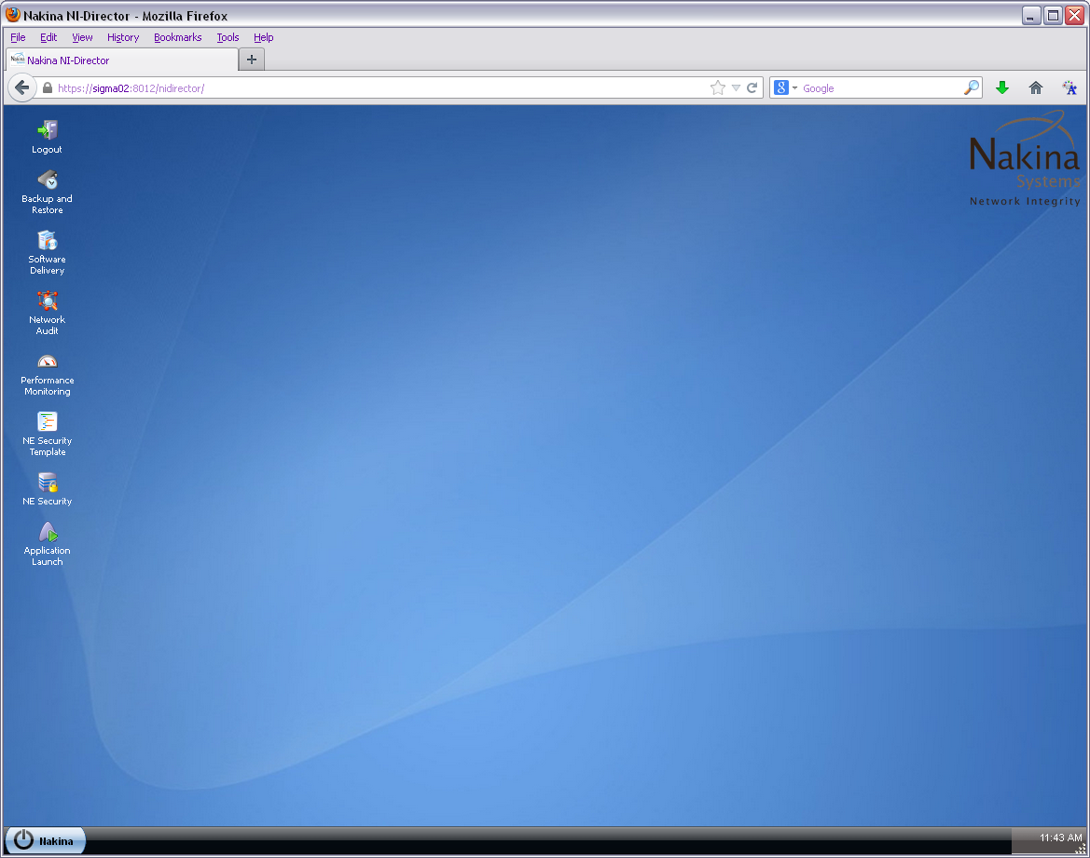
APPENDIX B: NI-Director, NE Manager Application

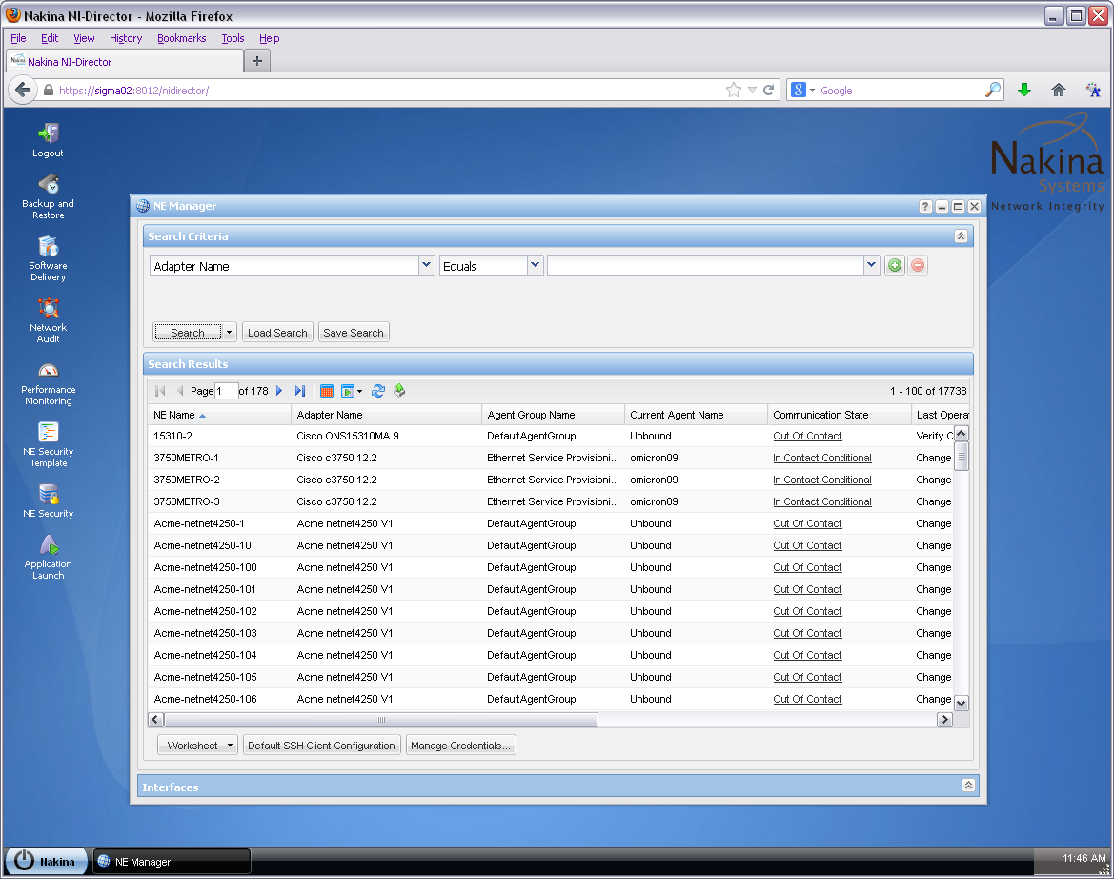
APPENDIX C: NI-Director, NE Manager Application, NE Configuration

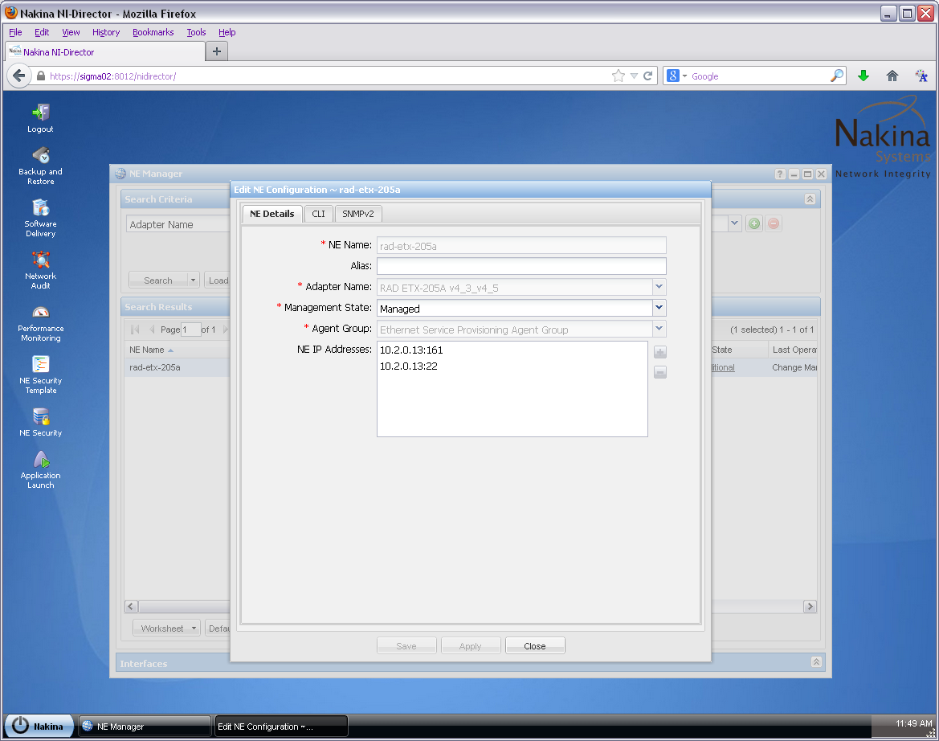

APPENDIX D: NI-Director, NE Security Application

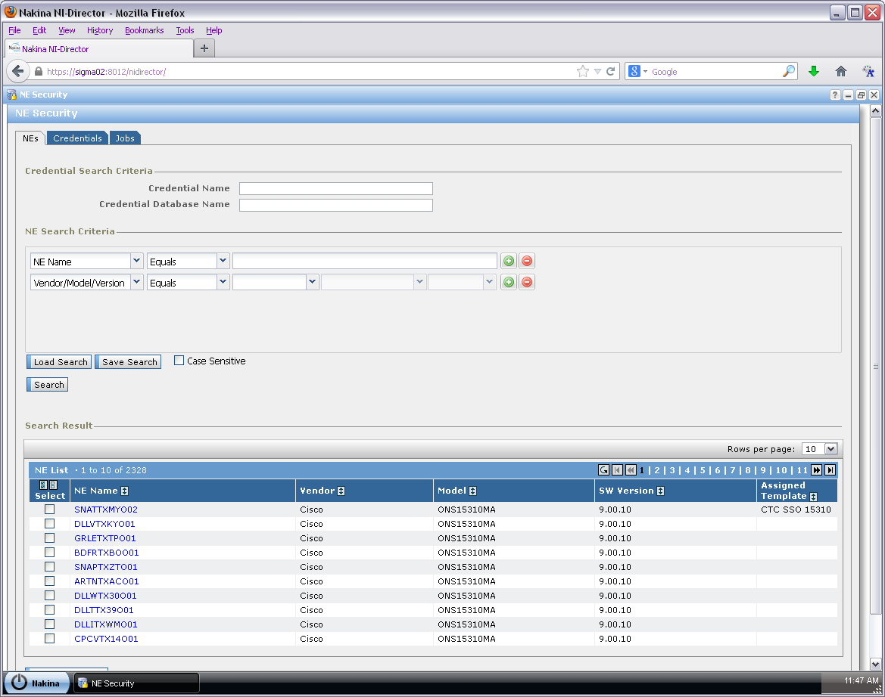

APPENDIX E: NI-Director, NE Security Template Application

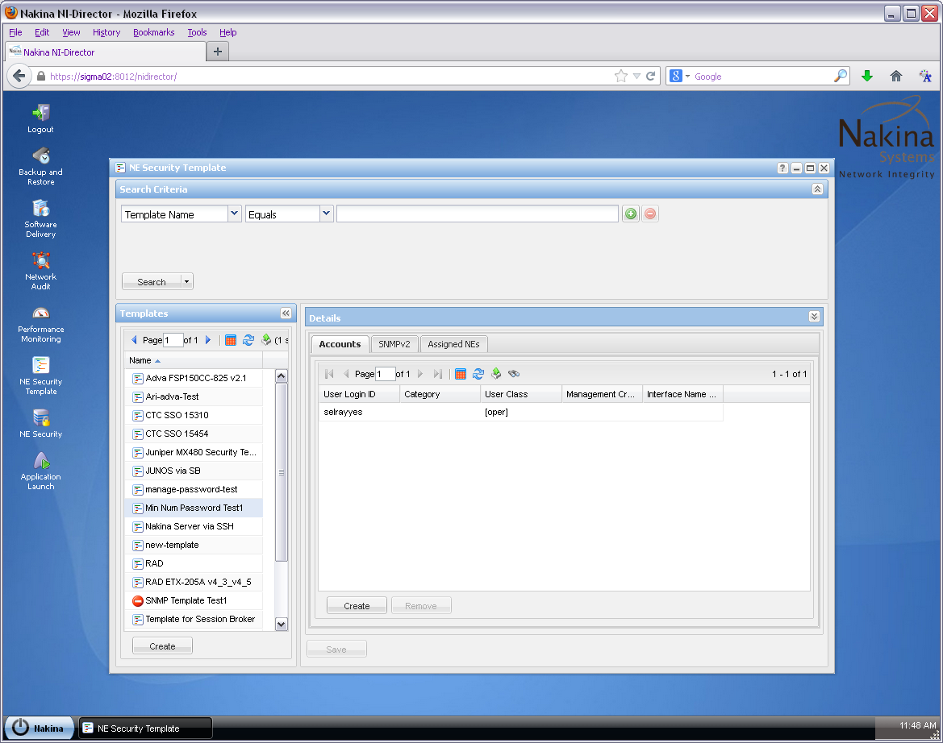

APPENDIX F: NI-Director, Log Manager Application

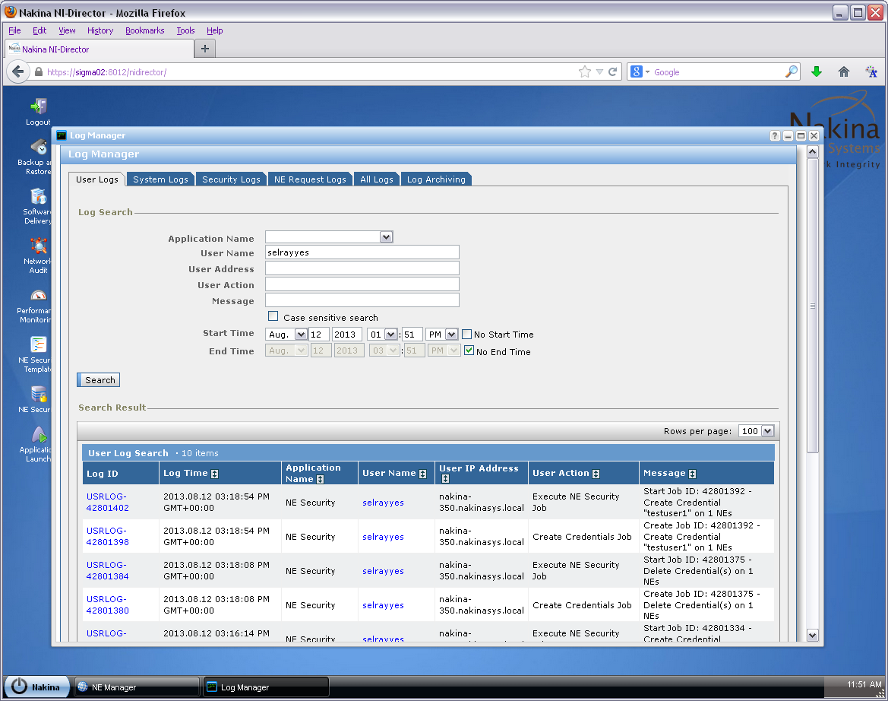

SUPERVISOR’S APPROVAL

As supervisor of CO-OP student Samira El-Rayyes, I, ________________________________, certify that, to the best of my knowledge, this report is entirely the student’s work and is free of confidential information to the extent that it can be read by university faculty members.

Signature _______________________________

Date ____________________________

